**Objective**: Use Naïve Gaussian elimination to solve the following equations:

10X1 + 2X2 - X3 = 27

-3X1 - 6X2 + 2X3 = - 61.5

X1 + X2 + 5X3 = - 21.5

**Solved by Theoretically:**

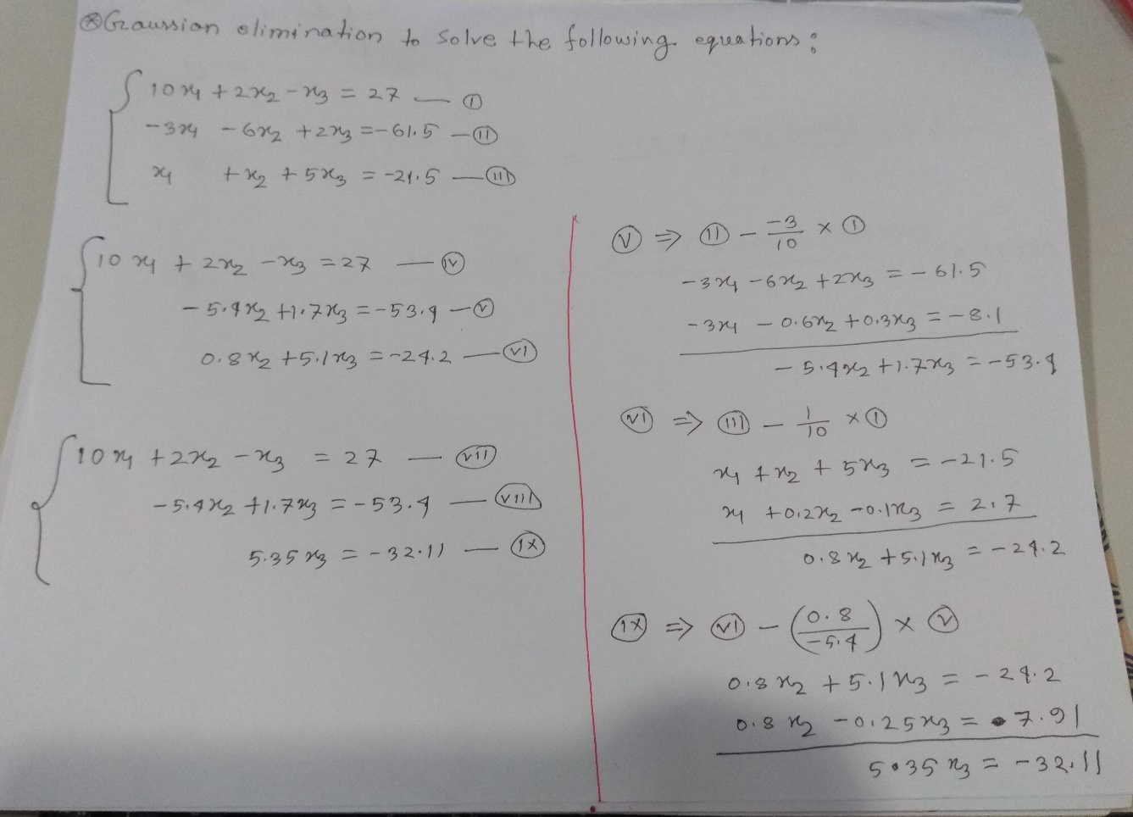

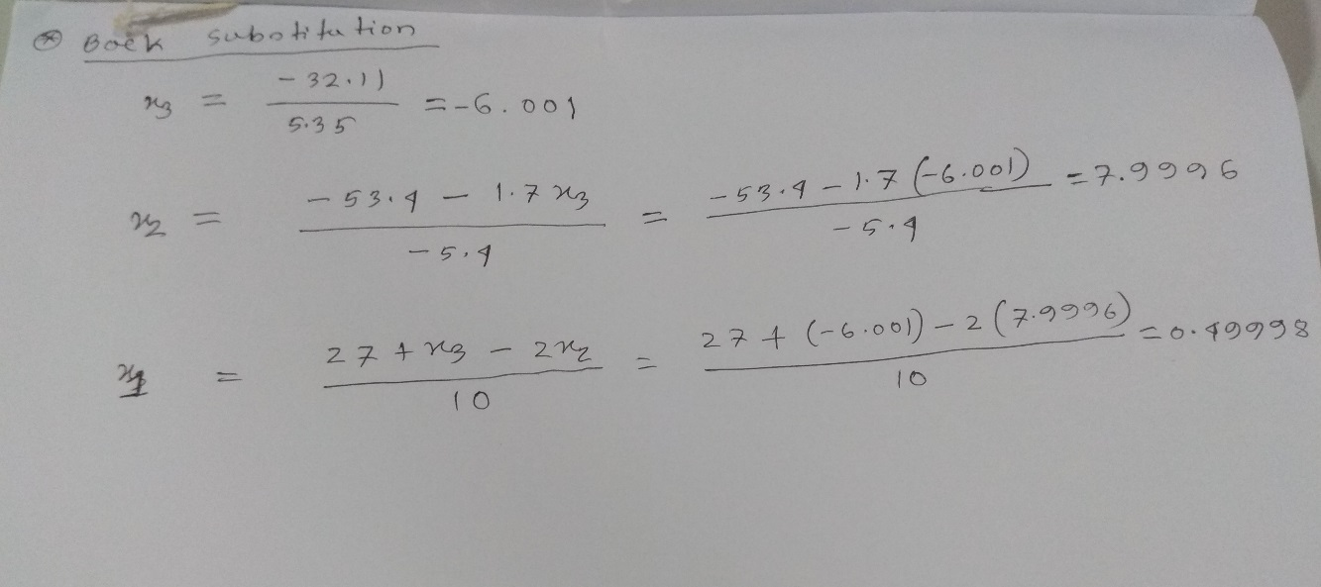

**Solved by Numerical Method using MATLAB:**

clc;

close all;

clear all;

A = [10,2,-1;

-3,-6,2;

1,1,5];

B= [27;

-61.5;

-21.5];

n = 3;

**%forward elimination**

for k = 1: n-1 %equations/row, for which respect, expected element of row

%will eliminate.

for i =k+1: n %Equations of those elements who will eliminate.

factor = A(i,k) / A(k,k);

for j = 1:n %for row wise calculation

A(i,j) = A(i,j) - factor * A(k,j)

%A(2,1) = A(2,1) - factor * A(1,1)

%A(2,2) = A(2,2) - factor * A(1,2)

%A(2,3) = A(2,3) - factor * A(1,3)

end

B(i) = B(i) - factor * B(k)

%B(2) = B(2) - factor * B(1)

%B(3) = B(3) - factor * B(2)

end

end

**%Back substitution**

x = zeros(1,n);

x(n) = B(n) / A(n,n);

for i = n-1: -1:1

sum = B(i);

for j = i+1:n

sum = sum - A(i,j) * x(j);

end

x(i) = sum / A(i,i);

end

disp(x)

**Outputs:**

**For I = 0**

A =

10.0000 2.0000 -1.0000

0 -5.4000 2.0000

1.0000 1.0000 5.0000

A =

10.0000 2.0000 -1.0000

0 -5.4000 1.7000

1.0000 1.0000 5.0000

B =

27.0000

-53.4000

-21.5000

**For I = 1**

A =

10.0000 2.0000 -1.0000

0 -5.4000 1.7000

0 1.0000 5.0000

A =

10.0000 2.0000 -1.0000

0 -5.4000 1.7000

0 0.8000 5.0000

A =

10.0000 2.0000 -1.0000

0 -5.4000 1.7000

0 0.8000 5.1000

B =

27.0000

-53.4000

-24.2000

**For I = 1**

A =

10.0000 2.0000 -1.0000

0 -5.4000 1.7000

0 0.8000 5.1000

A =

10.0000 2.0000 -1.0000

0 -5.4000 1.7000

0 0 5.1000

A =

10.0000 2.0000 -1.0000

0 -5.4000 1.7000

0 0 5.3519

B =

27.0000

-53.4000

-32.1111

**Our final outputs:**

X1 = 0.5000

X2 = 8.0000

X3 = -6.0000

**Discussion:**

Theoretical values are slightly different form values founded by solving practically or numerically. This is because of we count round value after decimal point in theoretically.

As we saw number of equations weren’t generalized in our implementation. Which was n=3.